9/19/2026
Instructor: Sir Mustajab
Submitted by: Wasif Ali
Reg id: 245187
Class: BSCS F24 B


BASICS OF PYTHON
Artificial Intelligence Lab
Lab No 02
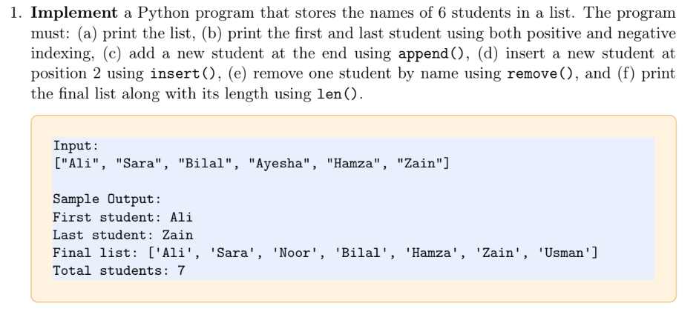
Code:
students = ["Ali", "Sara", "Bilal", "Ayesha", "Hamza", "Zain"]

print("Initial list:", students)
print("First student:", students[0])
print("Last student:", students[-1])

students.append("Usman")
students.insert(2, "Noor")
students.remove("Ayesha")

print("Final list:", students)
print("Total students:", len(students))

Output:
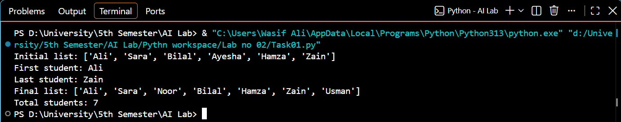
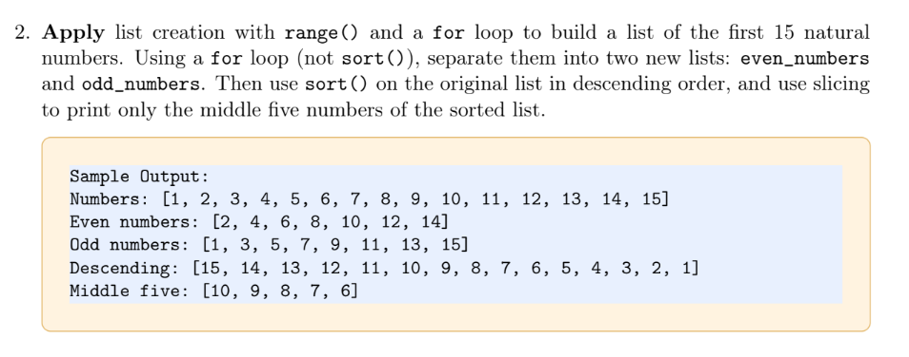
Code:
numbers = []
for i in range(1, 16):
numbers.append(i)

print("Numbers:", numbers)

even_numbers = []
odd_numbers = []

for num in numbers:
if num % 2 == 0:
even_numbers.append(num)
else:
odd_numbers.append(num)

print("Even numbers:", even_numbers)
print("Odd numbers:", odd_numbers)

numbers.sort(reverse=True)
print("Descending:", numbers)

middle_five = numbers[5:10]
print("Middle five:", middle_five)
Output:
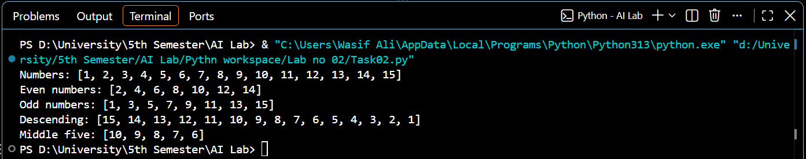
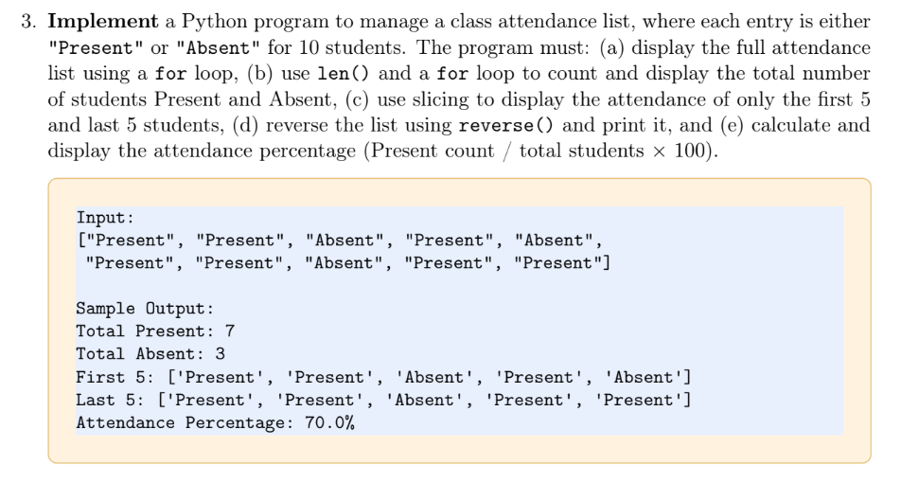
Code:
attendance = [
"Present", "Present", "Absent", "Present", "Absent",
"Present", "Present", "Absent", "Present", "Present"
]

print("Full Attendance:")
for hazri in attendance:
print(hazri, end=" ")
print("\n")

total_students = len(attendance)
present_count = 0
absent_count = 0

for status in attendance:
if hazri == "Present":
present_count += 1
elif hazri == "Absent":
absent_count += 1

print("Total Present:", present_count)
print("Total Absent:", absent_count)

print("First 5:", attendance[:5])
print("Last 5:", attendance[-5:])

attendance.reverse()
print("Reversed list:", attendance)

attendance_percentage = (present_count / total_students) * 100
print(f"Attendance Percentage: {attendance_percentage}%")

Output:
